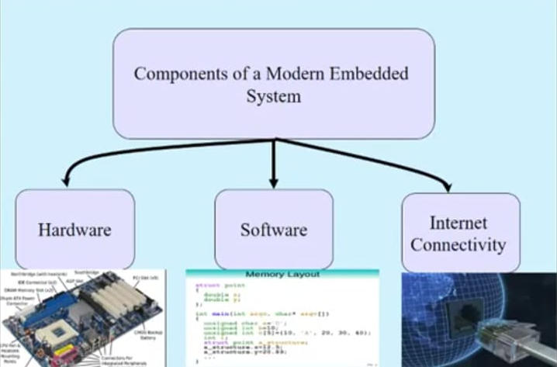
Internet of Things in Embedded System:

Automatic Air Conditioner:

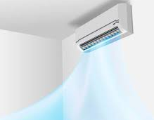

Three Modules Included In Automatic AC:
Human Detection Module
Temperature Detection Module
Remote Control Module

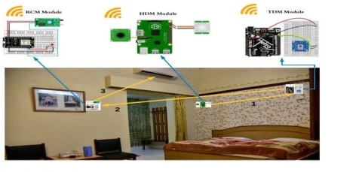

FlowChart of Automatic Air Conditioner:
